
University of Central Punjab
Faculty of Information Technology

Object Oriented Programming - Lab 06

NAME: MUHAMMAD ASMAR NAEEM
ROLL NO: L1F24BSCS0069
Topic
Static and constant functions, static and constant objects, and Working with Multiple Files.
Objective
- Understand the concept and usage of static functions and how they differ from non-static member functions.
- Learn the purpose and behavior of constant member functions in ensuring data protection and immutability.
- Explore the concept of static objects, their lifetime, and shared behavior across all class instances.
- Understand the role of constant objects and their restrictions in calling only constant member functions.
- Learn how to organize C++ programs across multiple files by separating class declarations (.h files) from definitions/implementations (.cpp files).
- Develop the ability to design modular and maintainable code using proper file structuring and object- oriented practices.
Outcomes
By the end of this Lab, you will be able to:
- Define and implement static functions and static objects in C++ classes to understand their scope and lifetime.
- Differentiate between constant and non-constant member functions, and apply them to maintain data integrity.
- Explain the concept of constant objects and their limitations in invoking only constant member functions.
- Demonstrate how static data members are shared among all objects of a class
- Organize C++ programs efficiently by separating class declarations (header files) and definitions (source files).
- Develop simple programs illustrating the use of static and constant members along with multi-file program structures in C++.
Content
The following sections will be covered during this lab session.
- Introduction to Static and Constant Members: Understanding the purpose and behavior of static and constant members in C++ classes.
- Static Functions and Objects: Exploring how static functions and objects maintain a single shared instance across all objects of a class and persist for the program’s lifetime.
- Constant Member Functions: Learning how constant functions ensure that member data cannot be modified and are essential for working with constant objects.
- Constant Objects: Understanding how constant objects enforce immutability by allowing access only to constant member functions.

Instructions
  - Indent your code properly.
  - Use meaningful variable and function names. Use the camelCase notation.
  - Use meaningful prompt lines/labels for all input/output.
  - In each file of your task either it is .cpp file or .h file Your name and roll no must be mentioned in the start of your file as comment. For example, //L1F20BSCS0000 – Ahmad
  - You are not allowed to use any built-in function.
  - You are required to complete the following tasks in lab timings

Task 01
Design a C++ program to create a class named Student that stores the following information:
- Char* name
- float marks
Tasks:
  - Implement a default constructor that initializes values to "Unknown" and 0.
  - Implement a parameterized constructor that accepts name and marks from the user.
  - Create setters and getters for both attributes.
  - Display the details of each student using a member function.
  - In main(), create multiple objects to demonstrate both constructors.
CODE:
HEADER FILE:
//L1F24BSCS0069-MUHAMMAD ASMAR NAEEM
#include<iostream>
using namespace std;

class Student {
private:
char* name;
float marks;

public:
Student(); // Default constructor
Student(char*, float); // Parameterized constructor
void setName(char*); // Setter for name
void setMarks(float); // Setter for marks
char* getName(); // Getter for name
float getMarks(); // Getter for marks
void display(); // Display details
~Student(); // Destructor
};
Student.cpp:
//L1F24BSCS0069-MUHAMMAD ASMAR NAEEM
#include "Student.h"

// Default constructor
Student::Student() {
name = new char[8];
name[0] = 'U';
name[1] = 'n';
name[2] = 'k';
name[3] = 'n';
name[4] = 'o';
name[5] = 'w';
name[6] = 'n';
name[7] = '\0';
marks = 0;
}

// Parameterized constructor
Student::Student(char* n, float m) {
int len = 0;
while (n[len] != '\0') {
len++;
}
name = new char[len + 1];
for (int i = 0; i < len; i++) {
name[i] = n[i];
}
name[len] = '\0';
marks = m;
}

// Setter for name
void Student::setName(char* n) {
int len = 0;
while (n[len] != '\0') {
len++;
}
delete[] name;
name = new char[len + 1];
for (int i = 0; i < len; i++) {
name[i] = n[i];
}
name[len] = '\0';
}

// Setter for marks
void Student::setMarks(float m) {
marks = m;
}

// Getter for name
char* Student::getName() {
return name;
}

// Getter for marks
float Student::getMarks() {
return marks;
}

// Display function
void Student::display() {
cout << "Name: " << name << endl;
cout << "Marks: " << marks << endl;
}

// Destructor
Student::~Student() {
delete[] name;
}
MAIN.CPP:
//L1F24BSCS0069-MUHAMMAD ASMAR NAEEM
#include "Student.h"

int main() {
// Object using default constructor
Student s1;
cout << "Default Constructor:" << endl;
s1.display();
cout << endl;

// Object using parameterized constructor
char n1[20] = "Ali";
Student s2(n1, 88.5);
cout << "Parameterized Constructor:" << endl;
s2.display();
cout << endl;

// Modifying using setters
char n2[20] = "Asmar";
s1.setName(n2);
s1.setMarks(95.0);
cout << "After using setters:" << endl;
s1.display();

return 0;
}
OUTPUT:
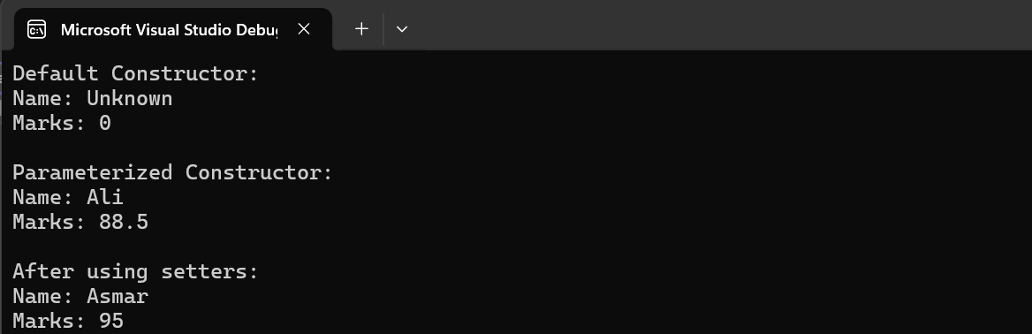

Task 02
Design a C++ class named Car having private data members:
- brandName(char*) 2. Price(float) Now perform the following operations:
  - Use a default constructor to assign initial values when an object is created.
  - Implement setters and getters to update and display car details.
  - Add a static data member named totalCars to keep track of how many Car objects have been created.
  - Increment totalCars inside the constructor each time a new object is created.
  - Implement a static function displayTotalCars() that displays the total number of car objects created.
  - Define a constant member function displayDetails() that displays car information without modifying any data members.
  - In the main() function, create multiple objects and display their data using getter functions.
CODE:
HEADER FILE:
//L1F24BSCS0069-MUHAMMAD ASMAR NAEEM
#include<iostream>
using namespace std;

class Car {
private:
char* brandName;
float price;
static int totalCars; // static data member

public:
Car(); // Default constructor
void setBrandName(char*); // Setter for brand name
void setPrice(float); // Setter for price
char* getBrandName(); // Getter for brand name
float getPrice(); // Getter for price
static void displayTotalCars(); // Static function
void displayDetails() const; // Constant member function
~Car(); // Destructor
};
Student.cpp
//L1F24BSCS0069-MUHAMMAD ASMAR NAEEM
#include "Car.h"

// Initialize static member
int Car::totalCars = 0;

// Default constructor
Car::Car() {
brandName = new char[8];
brandName[0] = 'U';
brandName[1] = 'n';
brandName[2] = 'k';
brandName[3] = 'n';
brandName[4] = 'o';
brandName[5] = 'w';
brandName[6] = 'n';
brandName[7] = '\0';
price = 0;
totalCars++;
}

// Setter for brand name
void Car::setBrandName(char* name) {
int len = 0;
while (name[len] != '\0') {
len++;
}
delete[] brandName;
brandName = new char[len + 1];
for (int i = 0; i < len; i++) {
brandName[i] = name[i];
}
brandName[len] = '\0';
}

// Setter for price
void Car::setPrice(float p) {
price = p;
}

// Getter for brand name
char* Car::getBrandName() {
return brandName;
}

// Getter for price
float Car::getPrice() {
return price;
}

// Static function to display total cars
void Car::displayTotalCars() {
cout << "Total Cars Created: " << totalCars << endl;
}

// Constant member function to display details
void Car::displayDetails() const {
cout << "Brand Name: " << brandName << endl;
cout << "Price: " << price << endl;
}

// Destructor
Car::~Car() {
delete[] brandName;
}
MAIN.CPP:
//L1F24BSCS0069-MUHAMMAD ASMAR NAEEM
#include "Car.h"

int main() {
cout << "Creating Car Objects..." << endl;

// Object 1 using default constructor
Car c1;
c1.displayDetails();
cout << endl;

// Object 2 using setters
Car c2;
char brand1[20] = "Toyota";
c2.setBrandName(brand1);
c2.setPrice(35000.50);
c2.displayDetails();
cout << endl;

// Object 3 using setters
Car c3;
char brand2[20] = "Honda";
c3.setBrandName(brand2);
c3.setPrice(28000.75);
c3.displayDetails();
cout << endl;

// Display total cars created
Car::displayTotalCars();

return 0;
}
OUTPUT:
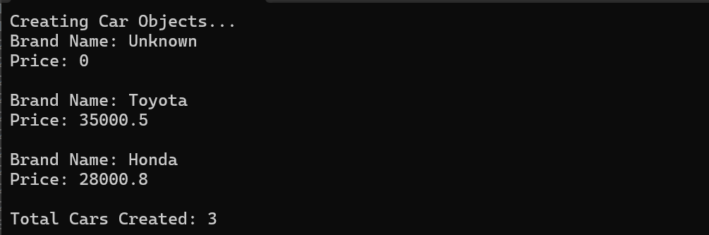

Task 03
Write a C++program that defines a class Rectangle with private datamembers:
  - float length
  - float width
Nowimplement the followingoperation;
  - Use a constructor to initialize the values.
  - Write aconstant member function getArea() that calculates and returns thearea.
  - Demonstrate in main() that a constant function cannotmodify data members.
CODE:
HEADER FILE:
//L1F24BSCS0069-MUHAMMAD ASMAR NAEEM
#include<iostream>
using namespace std;

class Rectangle {
private:
float length;
float width;

public:
Rectangle(float, float); // Constructor
float getArea() const; // Constant member function
void display() const; // Display rectangle details
};
Reactangle.cpp:
//L1F24BSCS0069-MUHAMMAD ASMAR NAEEM
#include "Rectangle.h"

// Constructor
Rectangle::Rectangle(float l, float w) {
length = l;
width = w;
}

// Constant member function to calculate area
float Rectangle::getArea() const {
// The following line would cause a compilation error if uncommented:
// length = 10; // Not allowed because getArea() is const
return length * width;
}

// Constant function to display rectangle details
void Rectangle::display() const {
cout << "Length: " << length << endl;
cout << "Width: " << width << endl;
cout << "Area: " << getArea() << endl;
}
MAIN.CPP:
//L1F24BSCS0069-MUHAMMAD ASMAR NAEEM
#include "Rectangle.h"

int main() {
Rectangle r1(5.5, 3.2);
cout << "Rectangle Details:" << endl;
r1.display();

// Demonstration of constant function restriction:
// If we try to modify a member inside getArea(), the compiler will give an error.

return 0;
}
OUTPUT:
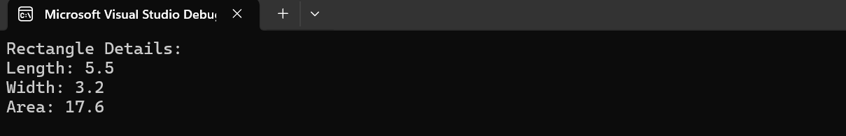

Task 04
Write a program to define a class BankAccount with data members:
- Char* accountNumber
- double balance
- a static double interestRate (shared among all accounts)
Nowimplement the followingoperation;
  - Initialize accountdetails through a parameterizedconstructor.
  - Implement a static function setInterestRate(double rate) to update the interest rate for all accounts.
  - Implement a display() function to showaccount detailsand the current interest rate.
  - Demonstratethe shared behavior of the static member in main().
CODE:
HEADER FILE:
//L1F24BSCS0069-MUHAMMAD ASMAR NAEEM
#include<iostream>
using namespace std;

class BankAccount {
private:
char* accountNumber;
double balance;
static double interestRate; // Shared among all accounts

public:
BankAccount(char*, double); // Parameterized constructor
static void setInterestRate(double); // Static function to set interest rate
void display(); // Display account details
~BankAccount(); // Destructor
};
BankAccount.cpp:
//L1F24BSCS0069-MUHAMMAD ASMAR NAEEM
#include "BankAccount.h"

// Initialize static member
double BankAccount::interestRate = 0.0;

// Parameterized constructor
BankAccount::BankAccount(char* accNum, double bal) {
int len = 0;
while (accNum[len] != '\0') {
len++;
}
accountNumber = new char[len + 1];
for (int i = 0; i < len; i++) {
accountNumber[i] = accNum[i];
}
accountNumber[len] = '\0';

balance = bal;
}

// Static function to set interest rate
void BankAccount::setInterestRate(double rate) {
interestRate = rate;
}

// Display function
void BankAccount::display() {
cout << "Account Number: " << accountNumber << endl;
cout << "Balance: " << balance << endl;
cout << "Interest Rate: " << interestRate << "%" << endl;
}

// Destructor
BankAccount::~BankAccount() {
delete[] accountNumber;
}
MAIN.CPP:
//L1F24BSCS0069-MUHAMMAD ASMAR NAEEM
#include "BankAccount.h"

int main() {
char acc1[20] = "ACC001";
char acc2[20] = "ACC002";

// Create two accounts with initial balances
BankAccount b1(acc1, 5000.0);
BankAccount b2(acc2, 7500.0);

// Set interest rate using static function
BankAccount::setInterestRate(5.5);

cout << "Account Details After Setting Interest Rate:\n";
b1.display();
cout << endl;
b2.display();
cout << endl;

// Change interest rate again
BankAccount::setInterestRate(6.2);
cout << "After Changing Interest Rate:\n";
b1.display();
cout << endl;
b2.display();

return 0;
}
OUTPUT:

Task 05 Design a transport authority wants to keep track of all registered vehicles using a centralized system. Design a class Vehicle with the following private data members:
- Int registrationNumber
- char* ownerName
- float engineCapacity
- astaticinttotalVehiclestostorethetotalnumberofregisteredvehicles. Implement the following:
  - A parameterized constructor to initialize vehicle details.
  - Astatic function getTotalVehicles() that returns the total number of registered vehicles.
  - A constant member function displayInfo() that prints vehicle details (without modifying data).
  - A setter function for updating ownername (non-constant). Main Function:
  - Create multiple objects(vehicles).
  - Create one constant object and call only constant member functions through it.
  - Displaythetotalnumberofvehiclesusingthestaticfunction(withoutanyobject).

CODE:

HEADER FILE:

//L1F24BSCS0069-MUHAMMAD ASMAR NAEEM
#include<iostream>
using namespace std;

class Vehicle {
private:
int registrationNumber;
char* ownerName;
float engineCapacity;
static int totalVehicles; // Shared among all vehicles

public:
Vehicle(int, char*, float); // Parameterized constructor
void setOwnerName(char*); // Setter for owner name
static int getTotalVehicles(); // Static function to get total count
void displayInfo() const; // Constant member function
~Vehicle(); // Destructor
};

Vehicle.cpp:

//L1F24BSCS0069-MUHAMMAD ASMAR NAEEM
#include "Vehicle.h"

// Initialize static member
int Vehicle::totalVehicles = 0;

// Parameterized constructor
Vehicle::Vehicle(int regNo, char* name, float cap) {
registrationNumber = regNo;
engineCapacity = cap;

int len = 0;
while (name[len] != '\0') {
len++;
}

ownerName = new char[len + 1];
for (int i = 0; i < len; i++) {
ownerName[i] = name[i];
}
ownerName[len] = '\0';

totalVehicles++;
}

// Setter for owner name
void Vehicle::setOwnerName(char* newName) {
int len = 0;
while (newName[len] != '\0') {
len++;
}

delete[] ownerName;
ownerName = new char[len + 1];
for (int i = 0; i < len; i++) {
ownerName[i] = newName[i];
}
ownerName[len] = '\0';
}

// Static function to get total number of vehicles
int Vehicle::getTotalVehicles() {
return totalVehicles;
}

// Constant function to display vehicle info
void Vehicle::displayInfo() const {
cout << "Registration Number: " << registrationNumber << endl;
cout << "Owner Name: " << ownerName << endl;
cout << "Engine Capacity: " << engineCapacity << " CC" << endl;
}

// Destructor
Vehicle::~Vehicle() {
delete[] ownerName;
}

MAIN.CPP:

//L1F24BSCS0069-MUHAMMAD ASMAR NAEEM
#include "Vehicle.h"

int main() {
char name1[20] = "Asmar";
char name2[20] = "Ali";
char name3[20] = "Ahmed";

// Creating multiple vehicle objects
Vehicle v1(101, name1, 1300.0);
Vehicle v2(102, name2, 1500.0);

cout << "Vehicle 1 Info:" << endl;
v1.displayInfo();
cout << endl;

cout << "Vehicle 2 Info:" << endl;
v2.displayInfo();
cout << endl;

// Updating owner name for v2
char newOwner[20] = "Bilal";
v2.setOwnerName(newOwner);

cout << "After updating owner name for Vehicle 2:" << endl;
v2.displayInfo();
cout << endl;

// Creating a constant object
const Vehicle v3(103, name3, 1000.0);
cout << "Constant Object (Vehicle 3) Info:" << endl;
v3.displayInfo(); // Only const functions can be called
cout << endl;

// Display total vehicles (static function called without object)
cout << "Total Registered Vehicles: " << Vehicle::getTotalVehicles() << endl;

return 0;
}

OUTPUT:

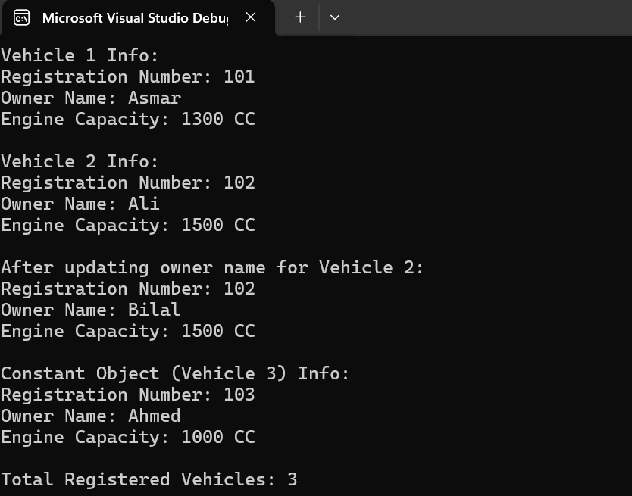

Task 06
The university needs a system to manage information about courses and maintain the total number of courses offered. Create a class Course with:
- Char* courseCode
- Char* instructorName
- int enrolledStudents
- a static int totalCourses to count total created objects. Implement the following opaertions;
  - A constructor to initialize all attributes.
  - A constant member function displayCourseInfo() to show all details.
  - A static function showTotalCourses() to display the total number of courses.
  - A setter function to modify the instructor name. Main Function:
  - Create 3 course objects using constructors.
  - Create one constant object of Course and try calling different functions (showing which are allowed).
  - Display total courses using the static function directly from the class (not through any object).
CODE:
HEADER FILE:
//L1F24BSCS0069-MUHAMMAD ASMAR NAEEM
#include<iostream>
using namespace std;

class Course {
private:
char* courseCode;
char* instructorName;
int enrolledStudents;
static int totalCourses; // Shared among all courses

public:
Course(char*, char*, int); // Constructor
void setInstructorName(char*); // Setter for instructor name
void displayCourseInfo() const; // Constant function to display info
static void showTotalCourses(); // Static function
~Course(); // Destructor
};
Course.cpp:
//L1F24BSCS0069-MUHAMMAD ASMAR NAEEM
#include "Course.h"

// Initialize static data member
int Course::totalCourses = 0;

// Constructor to initialize all attributes
Course::Course(char* code, char* instructor, int students) {
int len1 = 0;
while (code[len1] != '\0') {
len1++;
}
courseCode = new char[len1 + 1];
for (int i = 0; i < len1; i++) {
courseCode[i] = code[i];
}
courseCode[len1] = '\0';

int len2 = 0;
while (instructor[len2] != '\0') {
len2++;
}
instructorName = new char[len2 + 1];
for (int i = 0; i < len2; i++) {
instructorName[i] = instructor[i];
}
instructorName[len2] = '\0';

enrolledStudents = students;
totalCourses++;
}

// Setter function to modify instructor name
void Course::setInstructorName(char* newName) {
int len = 0;
while (newName[len] != '\0') {
len++;
}
delete[] instructorName;
instructorName = new char[len + 1];
for (int i = 0; i < len; i++) {
instructorName[i] = newName[i];
}
instructorName[len] = '\0';
}

// Constant member function to display course info
void Course::displayCourseInfo() const {
cout << "Course Code: " << courseCode << endl;
cout << "Instructor Name: " << instructorName << endl;
cout << "Enrolled Students: " << enrolledStudents << endl;
}

// Static function to display total number of courses
void Course::showTotalCourses() {
cout << "Total Courses Offered: " << totalCourses << endl;
}

// Destructor
Course::~Course() {
delete[] courseCode;
delete[] instructorName;
}
MAIN.CPP:

//L1F24BSCS0069-MUHAMMAD ASMAR NAEEM
#include "Course.h"

int main() {
char c1[10] = "CS101";
char c2[10] = "CS102";
char c3[10] = "CS103";

char inst1[20] = "Dr. Ahmed";
char inst2[20] = "Prof. Bilal";
char inst3[20] = "Sir Asmar";

// Creating three course objects
Course course1(c1, inst1, 40);
Course course2(c2, inst2, 55);
Course course3(c3, inst3, 35);

cout << "Course 1 Information:" << endl;
course1.displayCourseInfo();
cout << endl;

cout << "Course 2 Information:" << endl;
course2.displayCourseInfo();
cout << endl;

cout << "Course 3 Information:" << endl;
course3.displayCourseInfo();
cout << endl;

// Updating instructor name for course2
char newInstructor[20] = "Dr. Ali";
course2.setInstructorName(newInstructor);
cout << "After updating instructor for Course 2:" << endl;
course2.displayCourseInfo();
cout << endl;

// Creating a constant Course object
const Course constCourse((char*)"CS104", (char*)"Dr. Khan", 25);
cout << "Constant Course Object Information:" << endl;
constCourse.displayCourseInfo(); // Only const functions are allowed
cout << endl;

// Display total number of courses using static function (no object)
Course::showTotalCourses();

return 0;
}
OUTPUT:
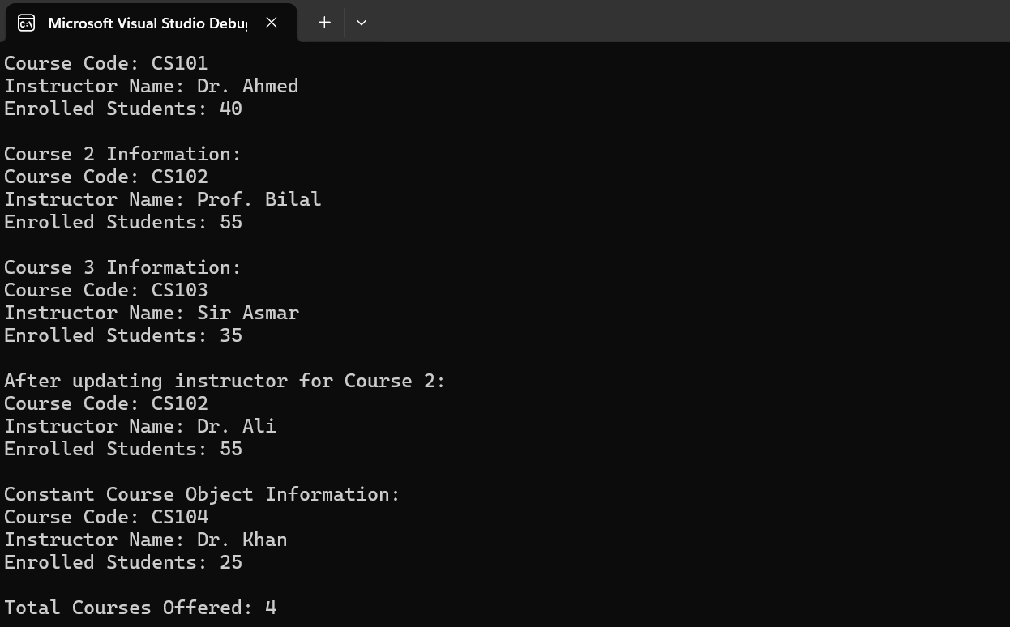

Task 07
A company maintains employee records and wants to ensure that sensitive payroll data cannot be modified once set. Create a class Employee with the following data members:
- int empID
- char* empName
- float salary
- a static int totalEmployees (shared counter). Implement the following operations:
  - A parameterized constructor for initialization.
  - A static function getTotalEmployees() to display the total number of employees.
  - A constant member function showDetails() to display employee data.
  - A setter to modify the salary of a specific employee. Main Function:
  - Create several Employee objects.
  - Declare one constant Employee object and demonstrate that only constant member functions can be accessed.
  - Call the static function to show the total number of employees created.
  - Try calling the static function using both an object and the class name, and note the difference.
CODE:
HEADER FILE:
//L1F24BSCS0069-MUHAMMAD ASMAR NAEEM
#include<iostream>
using namespace std;

class Employee {
private:
int empID;
char* empName;
float salary;
static int totalEmployees; // Shared among all Employee objects

public:
Employee(int, char*, float); // Parameterized constructor
void setSalary(float); // Setter to modify salary
void showDetails() const; // Constant function
static void getTotalEmployees(); // Static function
~Employee(); // Destructor
};
Employee.cpp:
//L1F24BSCS0069-MUHAMMAD ASMAR NAEEM
#include "Employee.h"

// Initialize static data member
int Employee::totalEmployees = 0;

// Parameterized constructor
Employee::Employee(int id, char* name, float s) {
empID = id;
salary = s;

int len = 0;
while (name[len] != '\0') {
len++;
}

empName = new char[len + 1];
for (int i = 0; i < len; i++) {
empName[i] = name[i];
}
empName[len] = '\0';

totalEmployees++;
}

// Setter to modify salary
void Employee::setSalary(float newSalary) {
salary = newSalary;
}

// Constant member function to display employee details
void Employee::showDetails() const {
cout << "Employee ID: " << empID << endl;
cout << "Employee Name: " << empName << endl;
cout << "Salary: " << salary << endl;
}

// Static function to display total number of employees
void Employee::getTotalEmployees() {
cout << "Total Employees: " << totalEmployees << endl;
}

// Destructor
Employee::~Employee() {
delete[] empName;
}
MAIN.CPP:
//L1F24BSCS0069-MUHAMMAD ASMAR NAEEM
#include "Employee.h"

int main() {
// Creating Employee objects
char name1[20] = "Ali";
char name2[20] = "Bilal";
char name3[20] = "Asmar";

Employee e1(101, name1, 55000);
Employee e2(102, name2, 60000);
Employee e3(103, name3, 65000);

cout << "Employee 1 Details:" << endl;
e1.showDetails();
cout << endl;

cout << "Employee 2 Details:" << endl;
e2.showDetails();
cout << endl;

// Modifying salary for employee 1
cout << "Updating salary for Employee 1..." << endl;
e1.setSalary(58000);
e1.showDetails();
cout << endl;

// Creating a constant employee object
const Employee e4(104, (char*)"Zain", 70000);
cout << "Constant Employee Details (only const functions allowed):" << endl;
e4.showDetails();
cout << endl;

// Display total employees using class name
cout << "Accessing static function using class name:" << endl;
Employee::getTotalEmployees();
cout << endl;

// Display total employees using object
cout << "Accessing static function using an object:" << endl;
e1.getTotalEmployees();

return 0;
}
OUTPUT:
